## NAMA: FERNALDY FERDINAND NIM: 2602068605 – LA09

LINK FIGMA: <https://www.figma.com/design/Zq5iFmESsaDQKDVTasRmud/VKellogg%E2%80%99s?node-id=269-1249&t=sEmlWZkm1i7oEEbQ-1>

## Soal

*Case*

**VKellogg’s**

**VKellogg’s** is a multinational company renowned for its production of breakfast foods and snacks. Founded by Will Keith Kellogg in 1906, the company is headquartered in Battle Creek, Michigan, United States. **VKellogg's** is well-known as one of the major cereal manufacturers worldwide and boasts a long history of food product innovation.

**VKellogg's** is presently in the process of strategizing the development of a website showcasing its products and recipes, aiming to expand its customer base globally. Initially, **VKellogg's** is focusing on crafting a **website prototype** and **company website** that aligns with the brand's image. The objective is to enhance customer service by providing a user-friendly online platform. **VKellogg's** has chosen you as the entrusted web designer to conceptualize the website prototype and build the official company website.

The **requirements** from **VKellogg’s** are described below:

* + - 1. **VKellogg’s** wants you to design the **website prototype** of all **five pages** before making the HTML files. The website prototype will be created using **Figma**. Ensure the website prototype that you created is **intentionally different** from the website that you will make later, even if the themes are the same. Each pagewill contain **header**, **navigation**, **content,** and **footer** as its structure. Consider the **color**, **layout**, and **consistency** when designing the prototype.

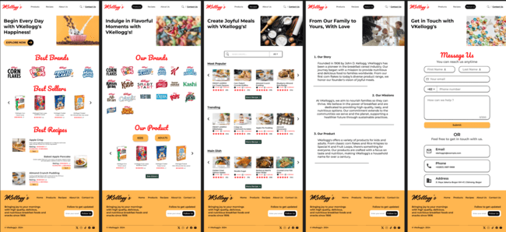

* + - 1. **VKellogg’s** Shop wants you to build the **website attractive**, **appealing**, **fully functional**, and make sure the website is **responsive**. The website should be accessible using a mobile phone in a perfect way. To achieve that, use **5 kinds of CSS property** and **JavaScript**. Use **meta** **viewport** **tag** and **media** **screen** **rule** that will be applied if the screen is **below** **768px** screen width.

* + - 1. The website consists of **five main pages**. They are **Home Page**, **Products Page**, **Recipes Page** **About Us Page**, and **Contact Us Page**. Below are the **requirements** for each page:
* **Home Page**

This page shows the **VKellogg’s best seller** products and **VKellogg’s best recipe**. This page also has a **banner** that displays **VKellogg’s**.

MOBILE

* **Products Page**

This page displays a list of **products** offered by **VKellogg's**. Ensure to include **the name and image** of each product to provide customers with a clearer understanding of the offerings, helping them make informed decisions on their purchases. Create **two separate sections** for **kids** and **adults** products. This page also features the **VKellogg's brand**, providing customers with a clear identification of the products and reinforcing the brand presence.

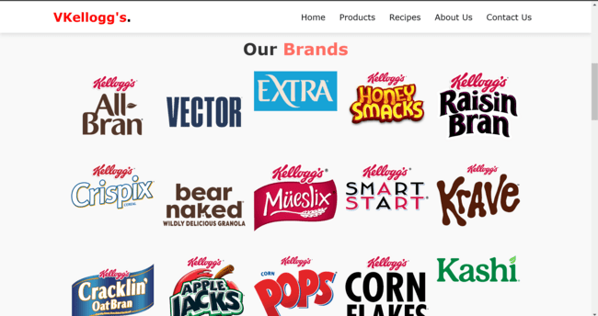

MOBILE

* **Recipes Page**

This page displays a list of all the **recipes** provided by **VKellogg’s**. From tempting breakfast options to tasty snacks and satisfying meals, the variety of culinary creations highlights **VKellogg's** dedication to offering a diverse and enjoyable culinary experience. Each recipe includes **serving** **sizes** and **preparation** **time.**

* **About Us Page**

This page provides **information** about **VKellogg’s**. Make sure the information provided is **relevant**, such as the **history**, and **mission** of VKellogg’s.

* **Contact Us Page**

This page provides a **contact us form**, Customer asked to submit some personal information such as **first name, last name, email address, and phone number.** They are also **asked to specify the nature of their inquiry.** You are asked to create **5 kinds of form components** and **5 kinds of validation**. For validation, you must create it using **JavaScript** and **don’t use regular expression**.

**Guidelines:**

* + - * 1. Design your website by observing the principles of **human and computer interaction**. Set up your site as **creative** as possible but still strive for **consistency**.
        2. The **website prototype** must be designed using **Figma** and make suretocreate some **features**, such as color and text style, effect, component, variant or interactive component, and navigation.
        3. Consider the **color**, **font**, **size**, and **layout** that you use to design the prototype and website.
        4. Use only **external** **CSS**. Internal or inline CSS will not be marked.
        5. Use **CSS box positioning** to design your web structure**,** do not use table for the layout.
        6. Consider the **language** you use, including spelling and grammar, feel free to choose either Bahasa or English, but you cannot have both at the same time.
        7. Make your website **responsive** so it can deliver in any size, particularly for **desktops**, **tablets,** and **mobile devices**.
        8. Any kinds of **framework** are **prohibited**. Do the project **with vanilla (original) HTML, CSS**, and **JavaScript**.
        9. Organize your files with **subdirectories**.
        10. Include **references** (link from a website, book, etc) that you use in creating the website.

Penjelasan

SEMUA PAGE DESKTOP:

* Terdapat Logo, dan navigasi menu yang dapat ditekan.
* Terdapat footer yang menunjukan logo yang dapat ditekan, icon media sosial yang dapat ditekan namun saya tidak membuatnya menuju kemana” karena jika saya membuatnya makan akan menuju home dari media sosial tersebut. Lalu ada Navigasi menu, dan terdapat input an gmail dan button submit/follow.

1. HOME PAGE:
   1. Terdapat banner
   2. Terdapat video tentang sereal, lalu terdapat button yang ketika ditekan akan menuju ke about us page
   3. Terdapat Best Sellers dan Best Recipe yang dimana ketika kursor diarahkan ke gambar tersebut maka, akan ada animasi yang menunjukan seperti “Go To Products” atau “Go To Recipes” dimana dari masing” itu akan menuju kehalaman product atau recipe.
2. PRODUCT PAGE:
   1. Menunjukan terdapat brand-brand apa saja
   2. Menunjukan seluruh produk-produk
   3. Lalu ada 3 button yang berbeda-beda yaitu All, Adults, dan Child. Ketiga button tersebut dapat ditekan dan hasilnya akan berbeda-beda
3. RECIPE PAGE:
   1. Terdapat Berbagai jenis menu. Yang dimana pada tampilan awal terdapat 4 gambar pada setiap masing-masing jenis.
   2. Lalu terdapat 2 button yaitu View Recipe dan More Recipe. Namun untuk View Recipe, saya tidak melanjutkan untuk membuat view recipe karena memakan waktu yang banyak. Untuk More Recipe, akan memperlihatkan semua masing-masing jenis produk.
4. ABOUT US PAGE:
   1. Terdapat penjelasan dari focus, visi, misi dan nilai-nilai
5. CONTACT US PAGE
   1. Terdapat fill input untuk First name, last name, email, nomor telfon, dan pesan.
   2. Masing masing memiliki ketentuan. Untuk firstname dan lastname harus lebih dari 2 huruf. Untuk email harus terdapat @gmail.com, untuk nomor telfon harus lebih dari 10 angka. Dan untuk inquiry dan pesan tidak boleh kosong.
   3. Dan terdapat titik dimana perusahaan vkellogg’s itu berada.

SEMUA PAGE MOBILE

* Terdapat Logo, dan sidebar menu yang dapat ditekan.
* Terdapat footer yang menunjukan logo yang dapat ditekan, icon media sosial yang dapat ditekan namun saya tidak membuatnya menuju kemana” karena jika saya membuatnya makan akan menuju home dari media sosial tersebut. Lalu ada Navigasi menu, dan terdapat input an gmail dan button submit/follow.

1. HOME PAGE:
   1. Terdapat banner
   2. Terdapat video tentang sereal, lalu terdapat button yang ketika ditekan akan menuju ke about us page
   3. Terdapat Best Sellers dan Best Recipe yang dimana ketika kursor diarahkan ke gambar tersebut maka, akan ada animasi yang menunjukan seperti “Go To Products” atau “Go To Recipes” dimana dari masing” itu akan menuju kehalaman product atau recipe.
2. PRODUCT PAGE:
   1. Menunjukan terdapat brand-brand apa saja
   2. Menunjukan seluruh produk-produk
   3. Lalu ada 3 button yang berbeda-beda yaitu All, Adults, dan Child. Ketiga button tersebut dapat ditekan dan hasilnya akan berbeda-beda
3. RECIPE PAGE:
   1. Terdapat Berbagai jenis menu. Yang dimana pada tampilan awal terdapat 2x2 gambar pada setiap masing-masing jenis.
   2. Lalu terdapat 2 button yaitu View Recipe dan More Recipe. Namun untuk View Recipe, saya tidak melanjutkan untuk membuat view recipe karena memakan waktu yang banyak. Untuk More Recipe, akan memperlihatkan semua masing-masing jenis produk.
4. ABOUT US PAGE:
   1. Terdapat penjelasan dari focus, visi, misi dan nilai-nilai
5. CONTACT US PAGE
   1. Terdapat fill input untuk First name, last name, email, nomor telfon, dan pesan.
   2. Masing masing memiliki ketentuan. Untuk firstname dan lastname harus lebih dari 2 huruf. Untuk email harus terdapat @gmail.com, untuk nomor telfon harus lebih dari 10 angka. Dan untuk inquiry dan pesan tidak boleh kosong.
   3. Dan terdapat titik dimana perusahaan vkellogg’s itu berada.

LINK REFERENSI:

* <https://www.wkkellogg.com/en-us/home.html>
* <https://www.w3schools.com/html/default.asp>
* <https://www.w3schools.com/css/default.asp>
* <https://www.w3schools.com/js/default.asp>
* <https://images.unsplash.com/photo-1556767576-cf0a4a80e5b8?q=80&w=2874&auto=format&fit=crop&ixlib=rb-4.0.3&ixid=M3wxMjA3fDB8MHxwaG90by1wYWdlfHx8fGVufDB8fHx8fA%3D%3D>
* <https://images.unsplash.com/photo-1685702563055-d1e74ffc53b3?q=80&w=2938&auto=format&fit=crop&ixlib=rb-4.0.3&ixid=M3wxMjA3fDB8MHxwaG90by1wYWdlfHx8fGVufDB8fHx8fA%3D%3D>
* <https://images.unsplash.com/photo-1495546968767-f0573cca821e?q=80&w=2831&auto=format&fit=crop&ixlib=rb-4.0.3&ixid=M3wxMjA3fDB8MHxwaG90by1wYWdlfHx8fGVufDB8fHx8fA%3D%3D>
* <https://images.unsplash.com/photo-1594895163638-89dfb5c0353d?q=80&w=2940&auto=format&fit=crop&ixlib=rb-4.0.3&ixid=M3wxMjA3fDB8MHxwaG90by1wYWdlfHx8fGVufDB8fHx8fA%3D%3D>
* <https://images.unsplash.com/photo-1560264280-88b68371db39?q=80&w=2940&auto=format&fit=crop&ixlib=rb-4.0.3&ixid=M3wxMjA3fDB8MHxwaG90by1wYWdlfHx8fGVufDB8fHx8fA%3D%3D>
* <https://i.pinimg.com/564x/23/7a/c0/237ac09b3d43f789d05bd2a58e2534d6.jpg>
* <https://i.pinimg.com/564x/73/13/02/731302eee2a4680f0bcb63204d41ea93.jpg>
* <https://i.pinimg.com/564x/64/28/c4/6428c4b948d7ffe8728044d06460e338.jpg>
* <https://cdnjs.cloudflare.com/ajax/libs/font-awesome/6.2.1/css/all.min.css>
* <https://developer.mozilla.org/en-US/docs/Web/CSS>
* <https://developer.mozilla.org/en-US/docs/Web/JavaScript>